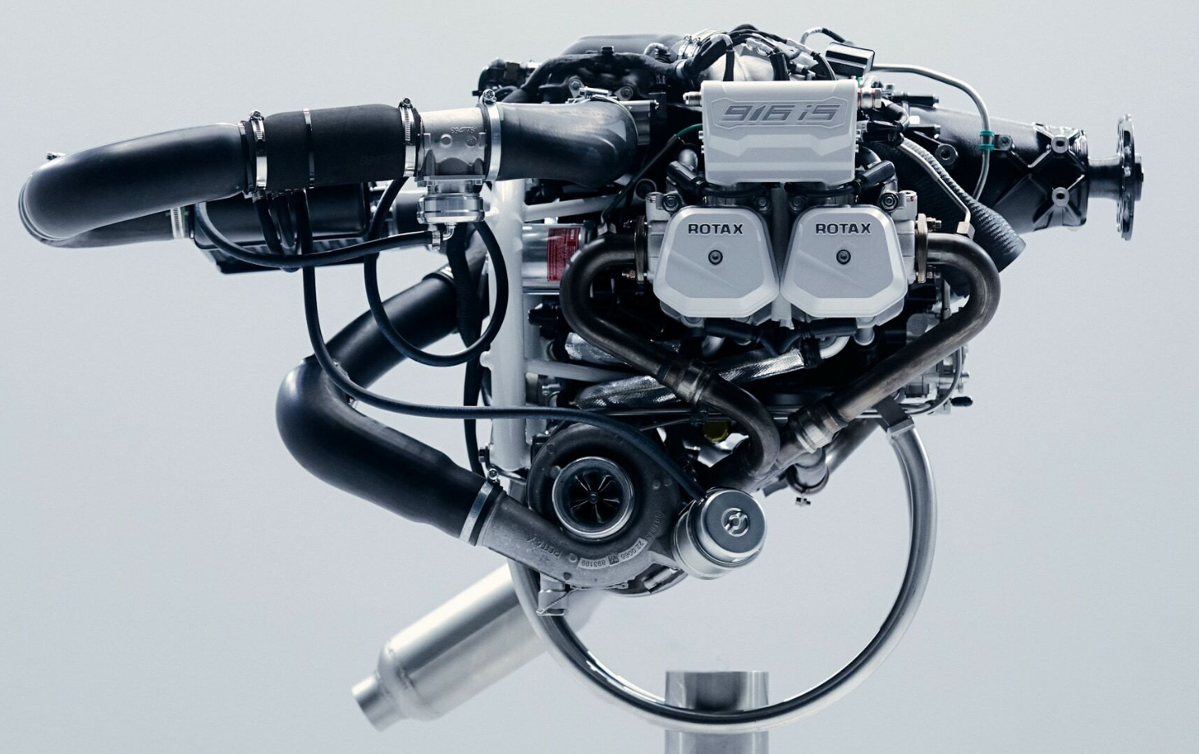
Motive Aero — Your Source for Rotax!

My name is Lauren Burton, and I have had the privilege of meeting many of you at EAA and SUAA meetings and other gatherings in the area. My husband Mike has been involved in aviation for almost 30 years, so my love affair with airplanes was more thrust upon me than an innate passion for flight. However, since learning about aviation and these engines, it has become a passion developed over time.

Rotax named Motive Aero, based in Hurricane, Utah, as the independent Service Center for the Western US in 2022. We thought we had a support system in the area, but when our partner unexpectedly and suddenly died, our company had to change plans to support this budding business. Not critical to our operations located in California, I was sent here to offer support from 2-6 weeks to get things up and running. I had passed through Hurricane often when I was in school up north on my way to family in Mesa. I always thought, “Who would ever choose to live in Hurricane?” It seemed so desolate and hot….or cold….or windy. But I knew my stay would be short and it was important.

My initial interactions with many of you were amazing. Whether it was because Steve Lemmon offered help and his truck to move cabinets and lumber, or whether it was Steve, Dave Houston, and about 4 other people who helped me get my hangar door unstuck because of my ignorance, or whether it was people helping me find supplies, support, or information about the community, I soon found out that the people that do live in Hurricane do so because they are incredibly generous, helpful, and supportive.

Since then, we have offered many Rotax maintenance training classes that draw people from all over the country and, in fact, the world. They all comment on how beautiful it is here. I have to stop and think, “Yeah, it really is.” One woman from Florida commented that the people are so nice! She said that even driving was a pleasure and when people waved at you, they used “way too many fingers!” Indeed, the people are what make this such an incredible place to be.
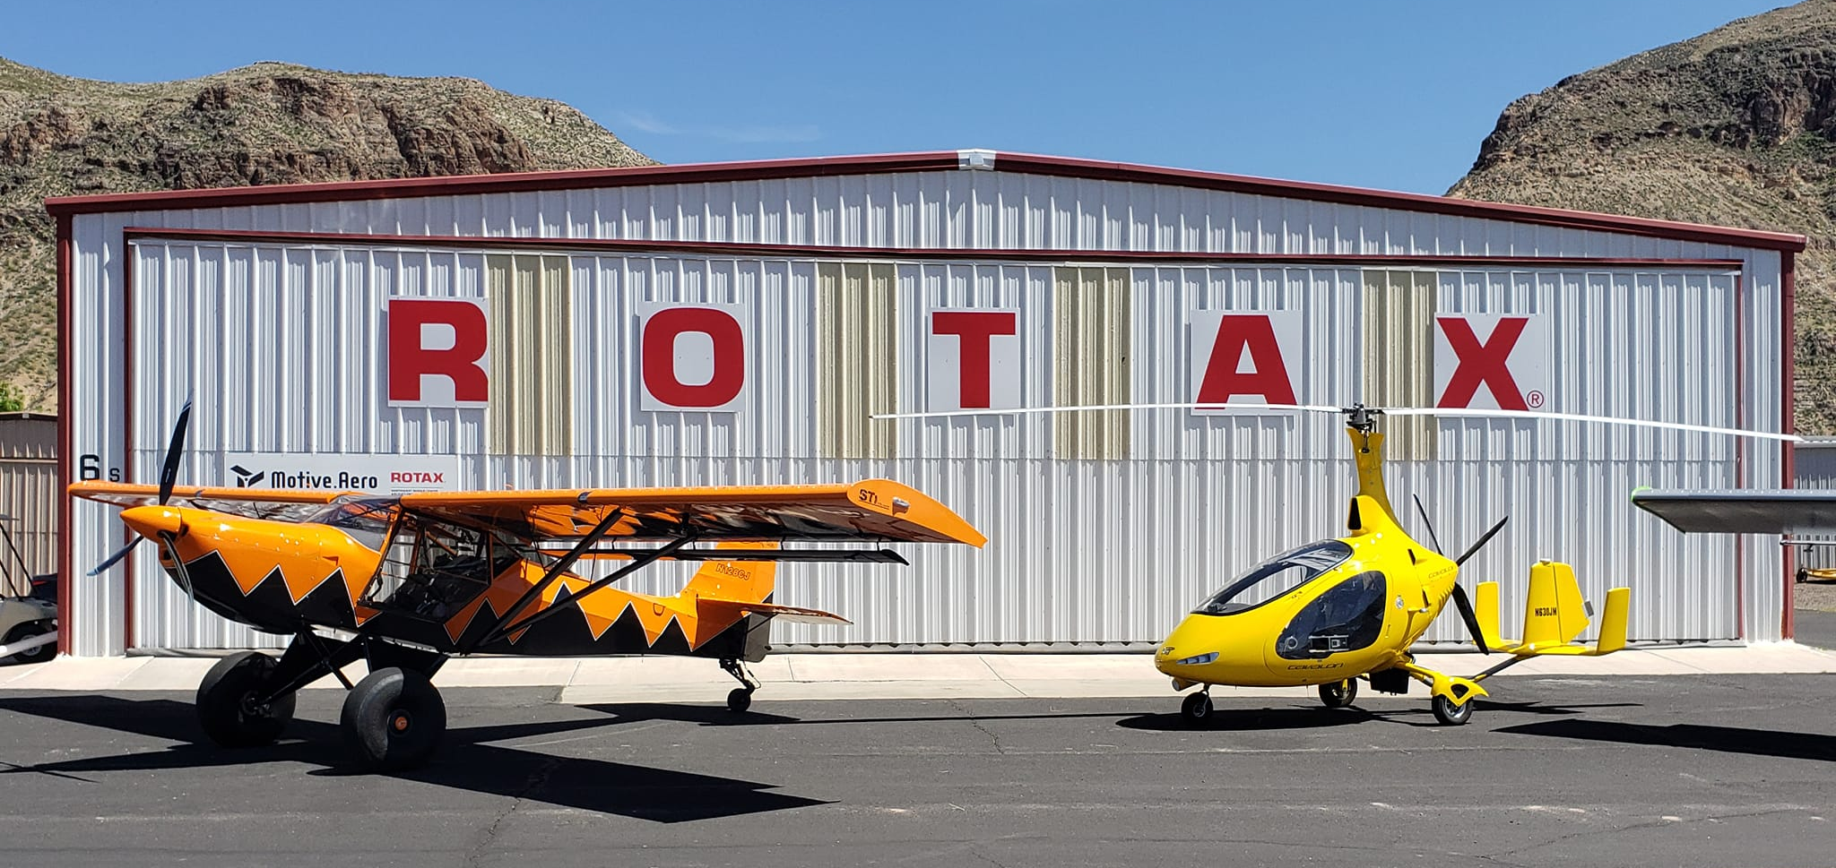
My 2-6 weeks has turned into four years and I have truly enjoyed getting to know many of you. I also see more and more Rotaxes on the field and we at Motive are here to support your needs. We have grown incredibly in this short time and will now be consolidating our businesses to bring the work here from California. This will allow us to help you (and us) even more. Meeting good people turning wrenches and maintaining certifications to work with you has been a highlight and I am seeing new aircraft coming into the market that show off the beauty and craftsmanship of the Rotax engines.

Although we have been serving the Rotax community for almost three years, I still receive phone calls from people who don’t know we are here to help. I would like to present a quick monthly update here in the newsletter, so you know what we are doing and how we can better serve you.
If you have any comments, suggestions, or need for Rotax parts, engines, or training, give me a call at (702) 989-7373 option 102. If you have technical questions, dial Mike at extension 101.

We would love to help however we can.
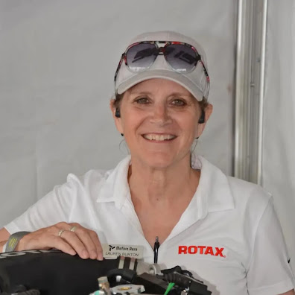
Lauren Burton
Executive Director for Motive Aero
Motive Aero
801-836-8602
Lauren@motive.aero

